**Berzerk**



Session: 2022 – 2026

**Submitted by:**

Iqra Taiq 2022-CS-29

**Supervised by:**

Prof. Dr. Muhammad Awais Hassan

**Table Of Contents**

Description 3

Game character Description 3

Player 3

Enemies 3

Rules and instructions 3

Goal of Game 3

Video Link:https://youtu.be/o4rEIrroP2w 4

WIREFRAMES 4

Game Complete Code 11

Class Details 11

Game Class 11

Game Cell Class 13

Game Direction Class 18

Game Object Class 20

GameObjectType Class 22

HorizonatlGhost Class 23

Ghost Class 25

PlayerBullet Class 27

RandomEnemy Class 29

Smart Enmey Class 31

Vertical Enemy Class 35

Berzerk Class 37

Bullet Class 40

Form Details 42

ExitForm 42

Form1 43

GameOver Form 48

Start Form 49

Program.cs 51

# Description

Berzerk places the player in a series of top-down, maze like rooms containing armed robot.it is simply a shooting game in which character traverses a maze to shoot robots. In berzerk an unnamed human fighting his way though randomly generated maxes. It has a yellow color in first level but as level change color also change. he loves to kill the anime like robot in this game. He spends his whole day to kill the all robot there is some food pallet in this game when human eat this food pallet he gains some power.

He randomly generated mazes overrun with killer robots. the aim is to destroy all robots. When he destroys all robots he moves in next level with different color. the number of enemy increase with next level. Two control keys implemented to provide the player with more precise control, enemies with different behaviors were added to make the game challenging. Coming into contact with an enemy costs the player one life, but extra lives can be earned at certain point total.

The left arrow key control the movement of character, while the right key control the direction

# Game character Description

## Player

A human unnamed character is the main character which is known by his human like shape.

He is loves to kill the enemies. He is the hero of the game, admired for his bravery and determination in the face of danger.

## Enemies

There are almost Three enemies in game. They all have multiple colors. They all want to kill the main player. One enemy move random at the top of the maze it can generate the bullets left and right both side. Second enemy move up and down it can generate it’s bullets left side.

# Rules and instructions

Player can generate bullets at right side. When bullets hit with enemies **Score** will be increase and the **specific enemy’ health** will be decrease. When the enemies’ bullets hit the Player the health of Player will decrease. When the Player health reaches at Zero you will lost, and when all enemies Health reaches at zero you will win the game.

# Goal of Game

The goal of the game is to kill all robot (enemy) that have been across the maze.

# Video Link:https://youtu.be/o4rEIrroP2w

**WIREFRAMES**

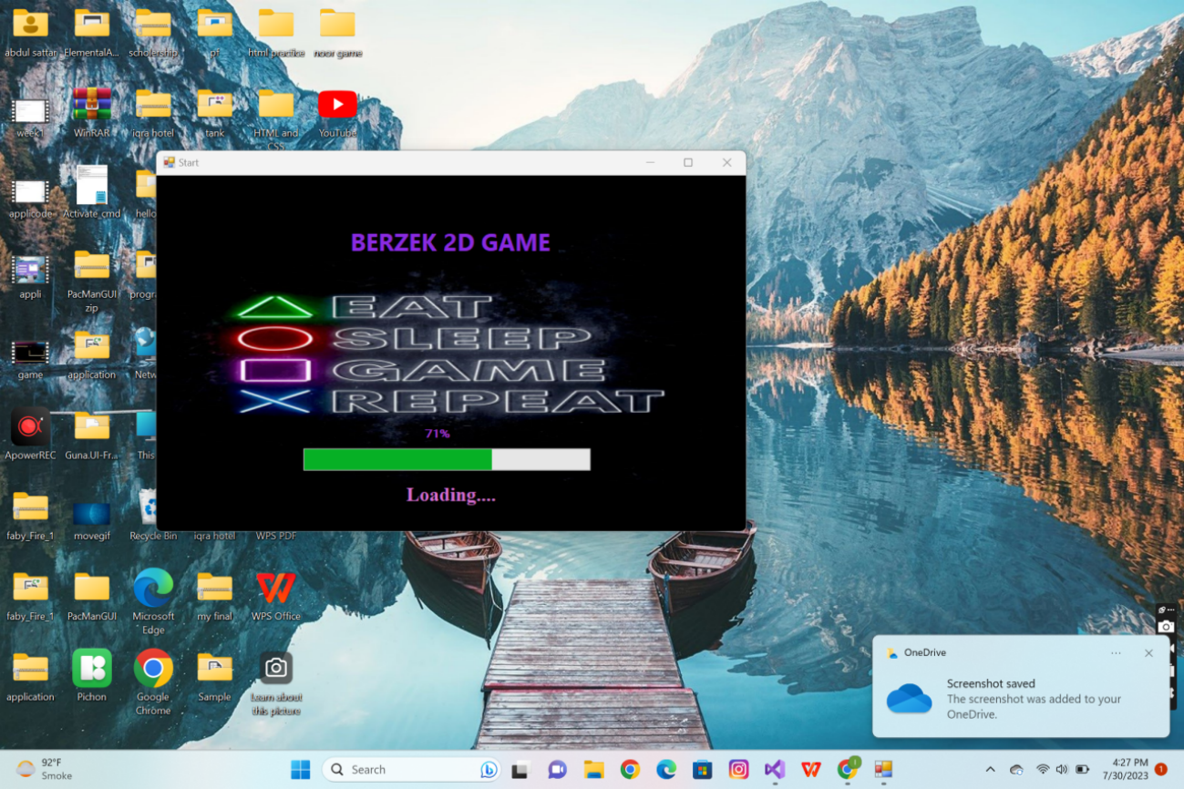

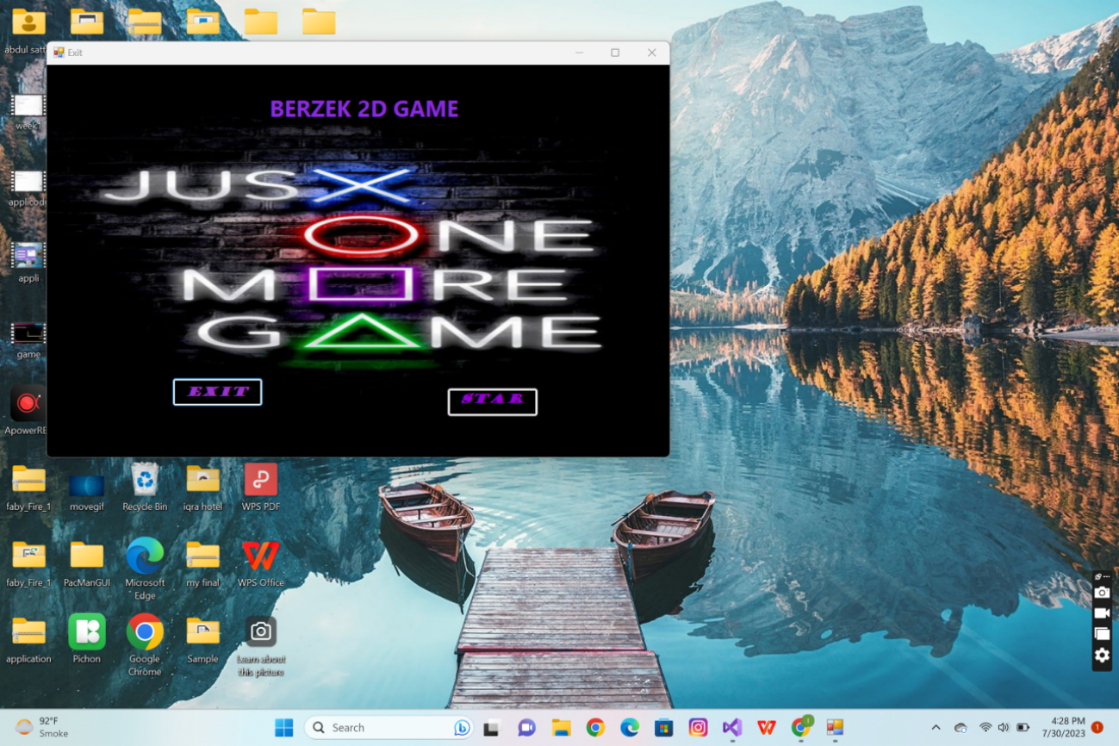

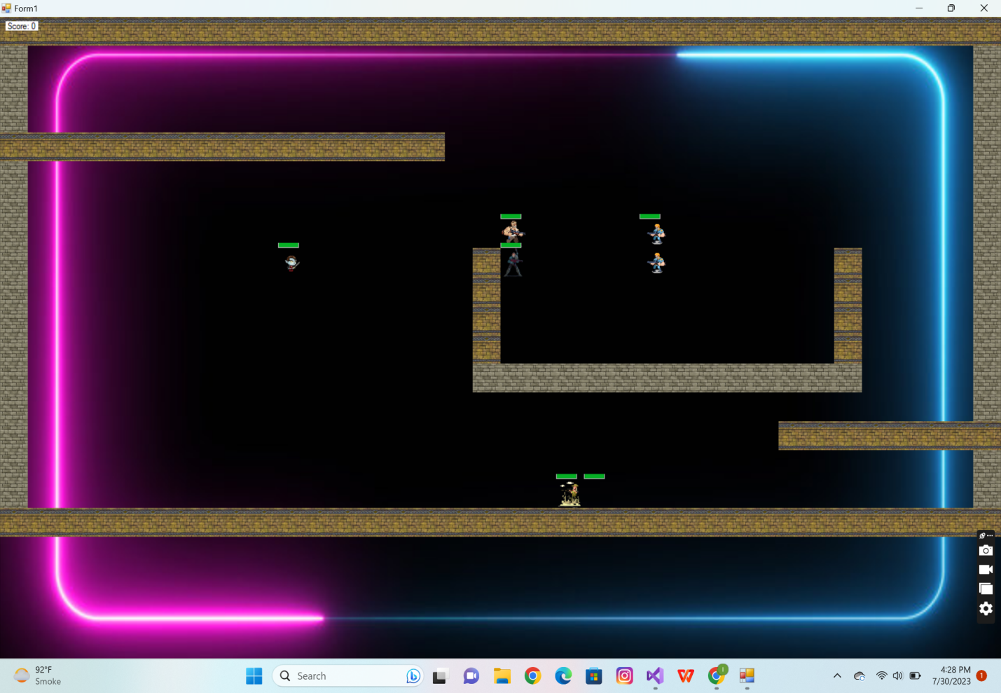

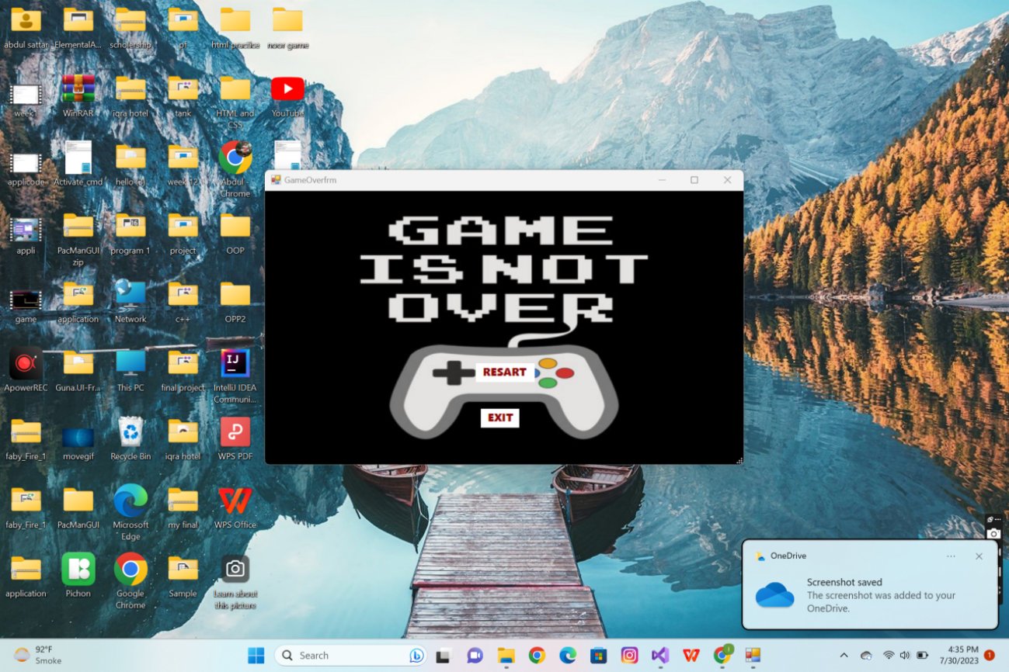

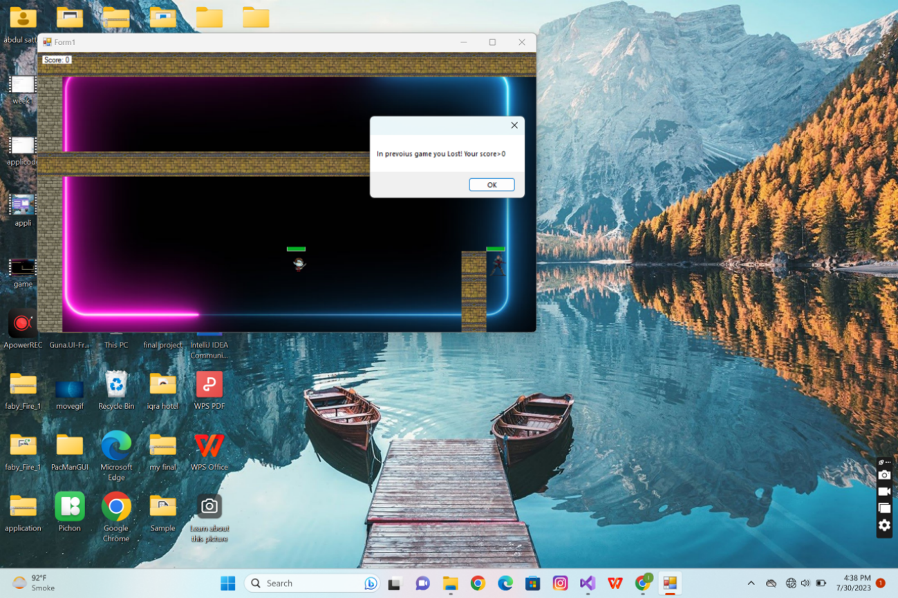

**CRC Diagrams:**

**Forms Crc:**

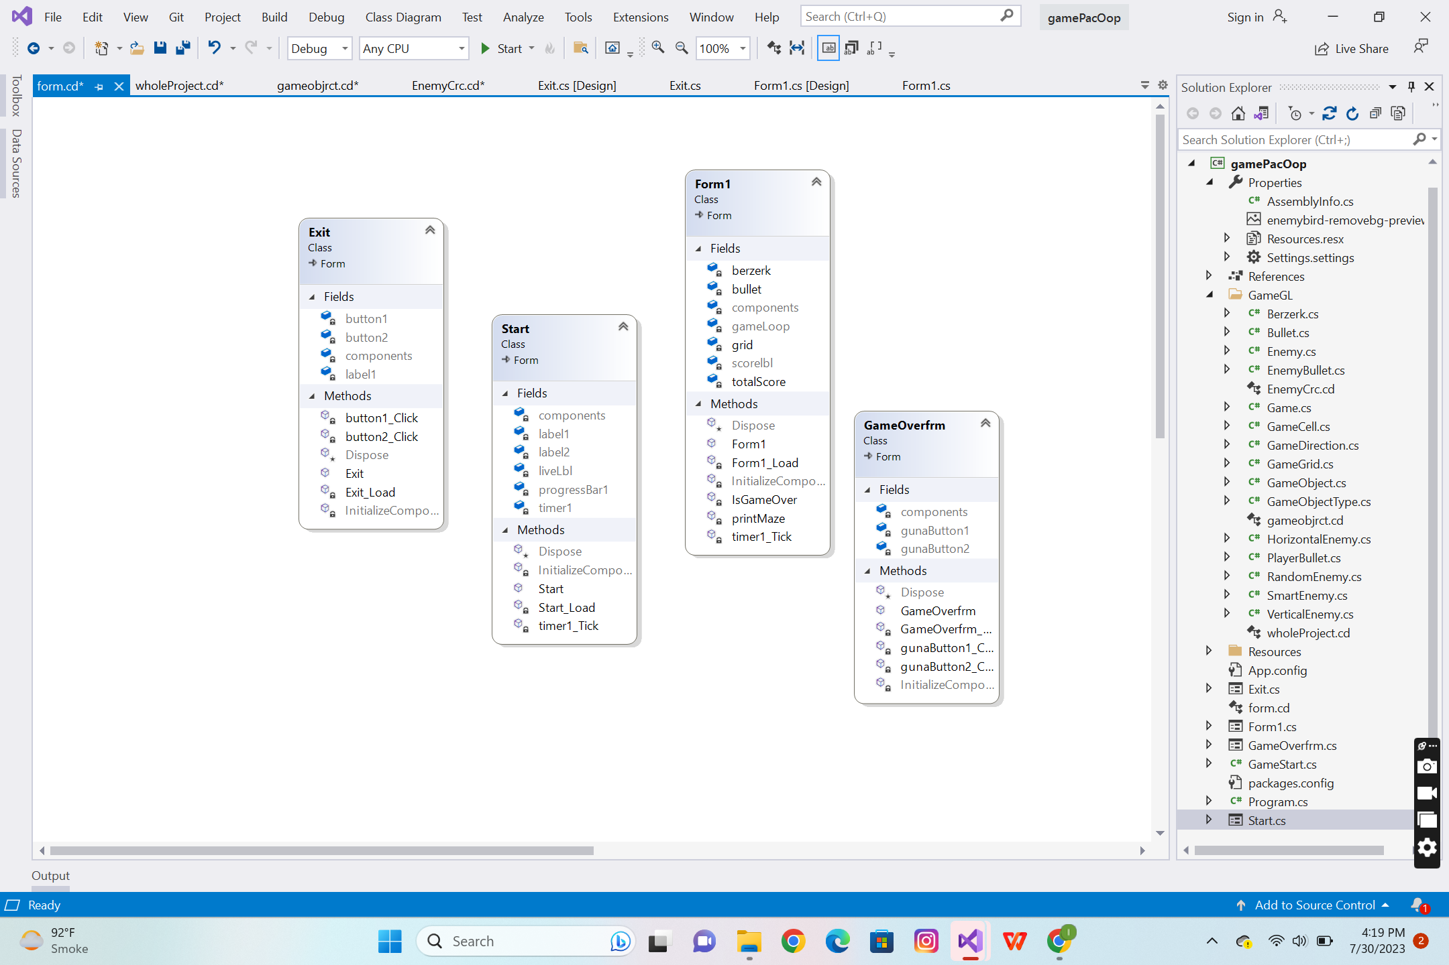

**Whole Project Crc**

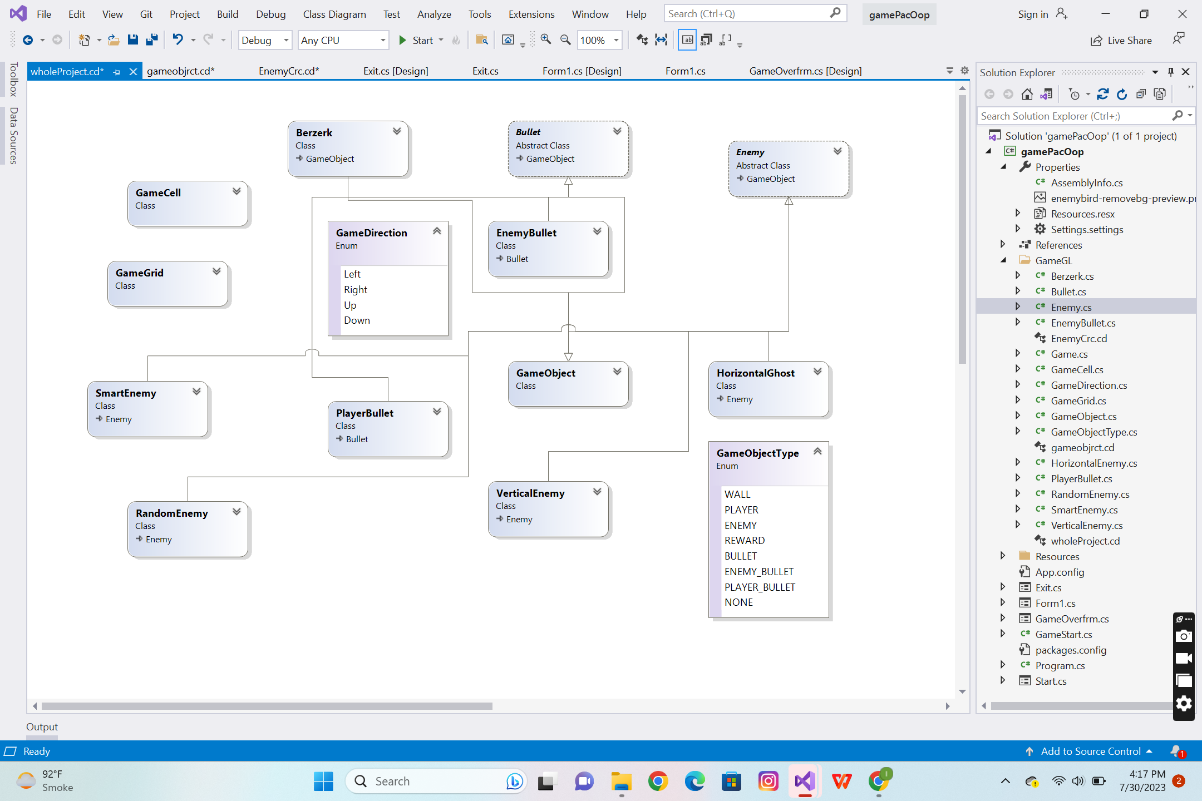

**Inherited Classes CRC**

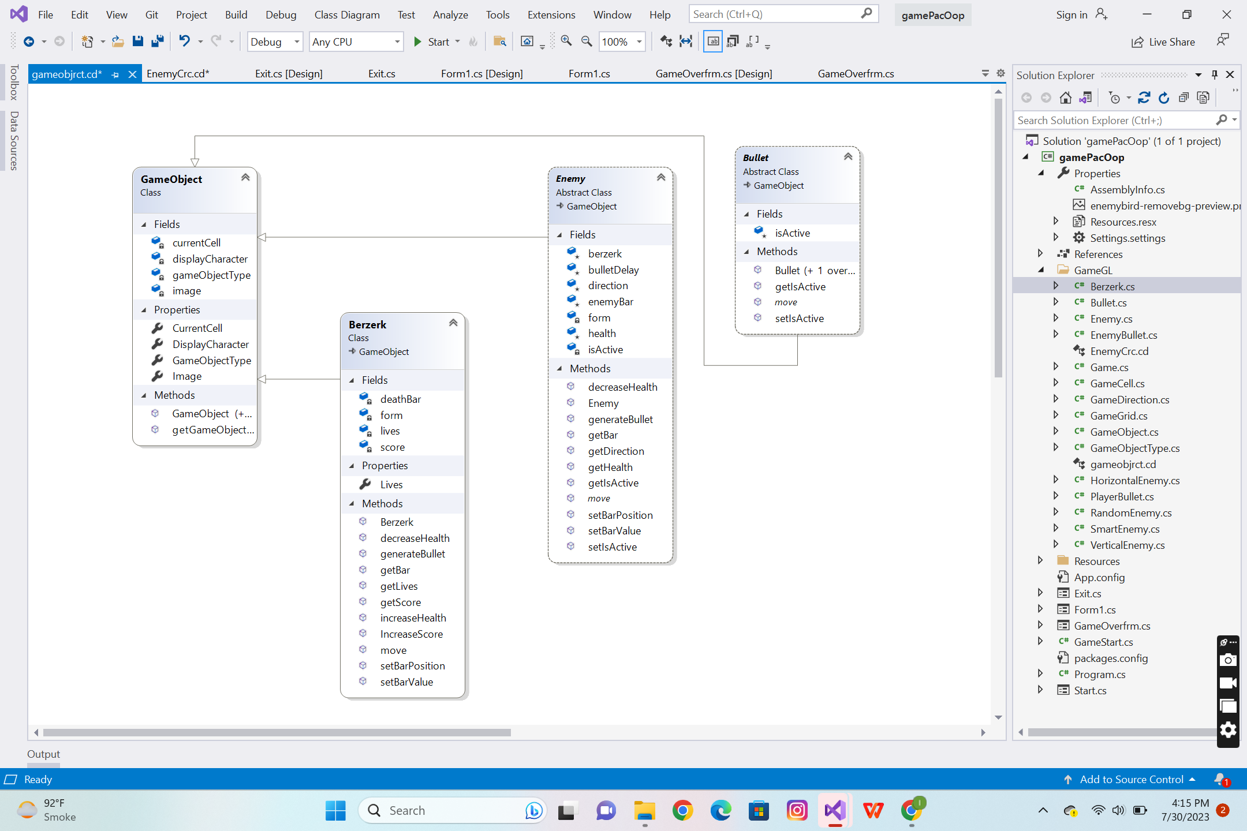

**EnemysClassesInherited CRC**

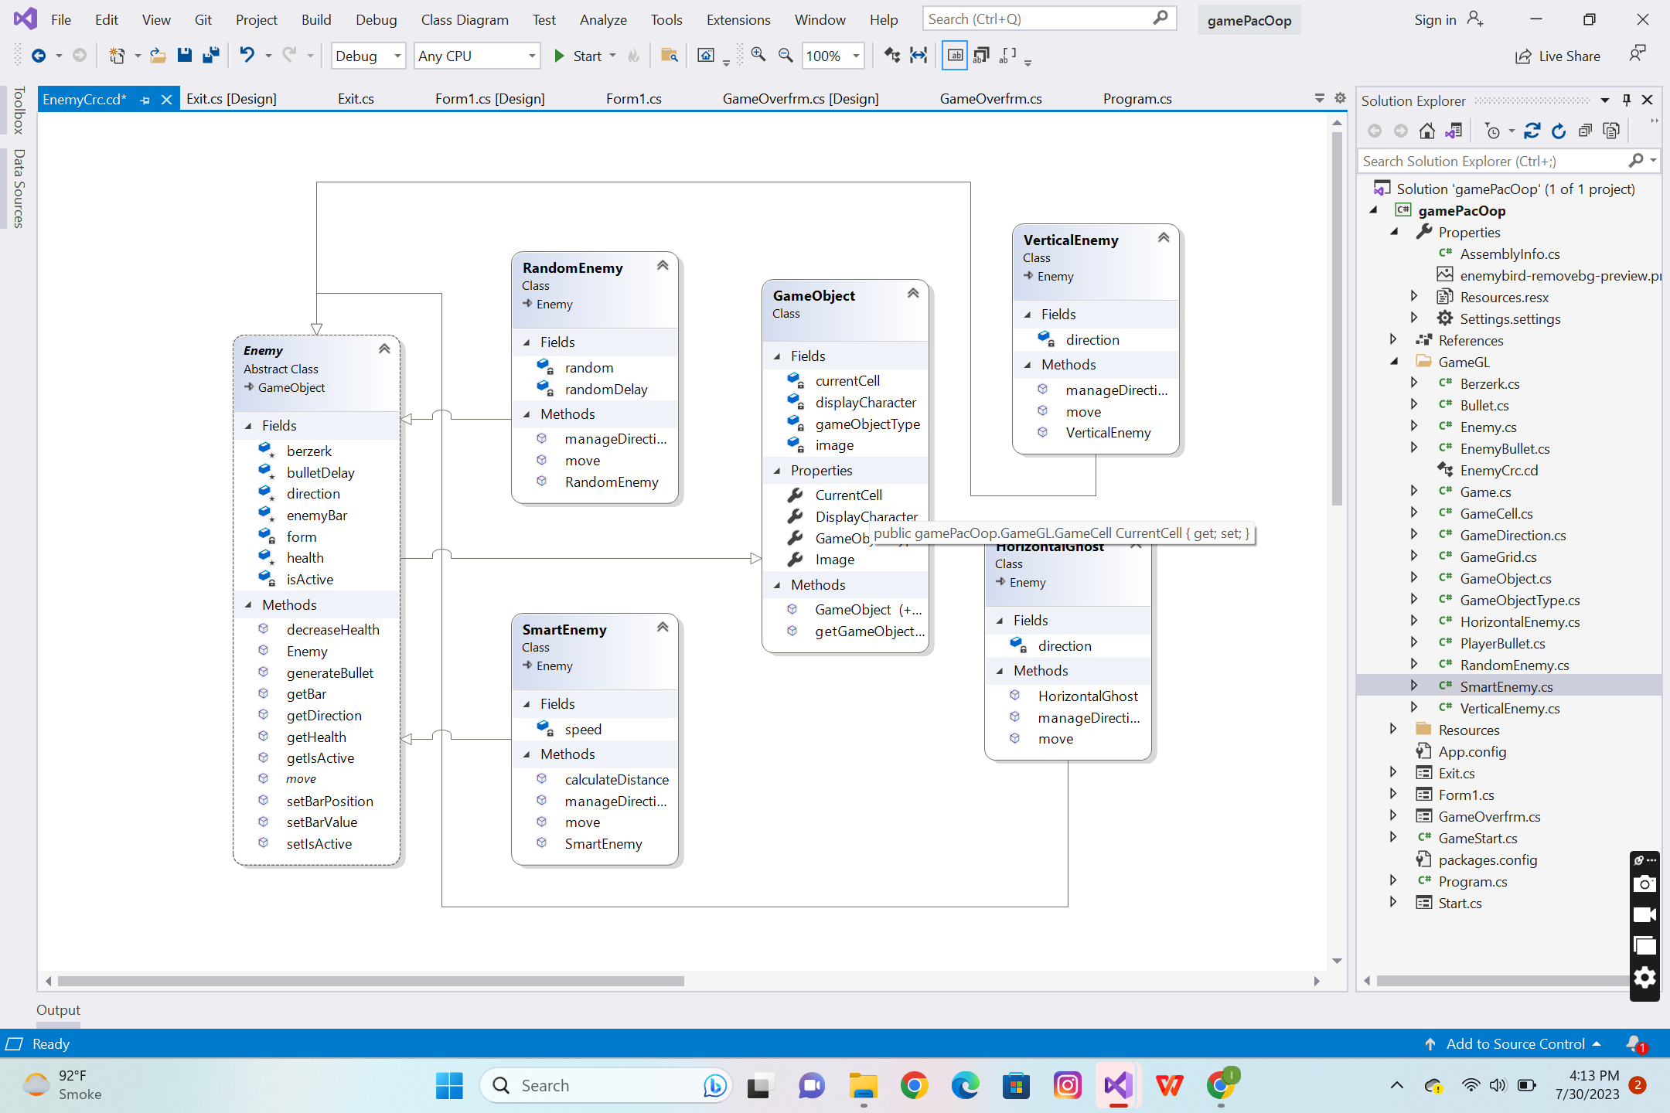

**Game Complete Code**

## **Class Details**

### **Game Class**

using System;

using System.Collections.Generic;

using System.Linq;

using System.Text;

using System.Threading.Tasks;

using System.Drawing;

using System.Windows.Forms;

namespace Berzerk.GameGL

{

class Game

{

public static GameGrid grid;

public static Berzerk berzerk;

public static List<Bullet> bulletsToRemove = new List<Bullet>();

public static List<Enemy> ghosts = new List<Enemy>();

public static List<EnemyBullet> enemyBullets = new List<EnemyBullet>();

public static GameObject getBlankGameObject()

{

GameObject blankGameObject = new GameObject(GameObjectType.NONE, null);

return blankGameObject;

}

public static Image getGameObjectImage(char displayCharacter)

{

Image img = null;

if (displayCharacter == '|' || displayCharacter == '%')

{

img = gamePacOop.Properties.Resources.wal;

}

if (displayCharacter == '#')

{

img = gamePacOop.Properties.Resources.verticalWall;

}

if (displayCharacter == 'P' || displayCharacter == 'p')

{

img = gamePacOop.Properties.Resources.player;

}

if (displayCharacter == 'H' || displayCharacter == 'h')

{

img = gamePacOop.Properties.Resources.horiEnemy;

}

if (displayCharacter == 'V' || displayCharacter == 'v')

{

img = gamePacOop.Properties.Resources.verticalEnemy;

}

if (displayCharacter == 'S' || displayCharacter == 's')

{

img = gamePacOop.Properties.Resources.pl;

}

if (displayCharacter == 'R' || displayCharacter == 'r')

{

img = gamePacOop.Properties.Resources.enemy3;

}

if (displayCharacter == 'F' || displayCharacter == 'f')

{

img = gamePacOop.Properties.Resources.fire;

}

return img;

}

}

}

### Game Cell Class

using System;

using System.Collections.Generic;

using System.Linq;

using System.Text;

using System.Threading.Tasks;

using System.Drawing;

using System.Windows.Forms;

namespace Berzerk.GameGL

{

class GameCell

{

int row;

int col;

GameObject currentGameObject;

GameGrid grid;

PictureBox pictureBox;

const int width = 40;

const int height = 40;

public GameCell(int row, int col, GameGrid grid)

{

this.row = row;

this.col = col;

pictureBox = new PictureBox();

pictureBox.Left = col * width;

pictureBox.Top = row * height;

pictureBox.Size = new Size(width, height);

pictureBox.SizeMode = PictureBoxSizeMode.Zoom;

pictureBox.BackColor = Color.Transparent;

this.grid = grid;

}

public GameCell()

{

}

public void setGameObject(GameObject gameObject)

{

currentGameObject = gameObject;

pictureBox.Image = gameObject.Image;

}

public GameCell nextCell(GameDirection direction)

{

if (direction == GameDirection.Left)

{

if (this.col > 0)

{

GameCell ncell = grid.getCell(row, col - 1);

if (ncell.CurrentGameObject.GameObjectType == GameObjectType.NONE || ncell.CurrentGameObject.GameObjectType == GameObjectType.REWARD)

{

return ncell;

}

}

}

if (direction == GameDirection.Right)

{

if (this.col < grid.Cols - 1)

{

GameCell ncell = grid.getCell(this.row, this.col + 1);

if (ncell.CurrentGameObject.GameObjectType == GameObjectType.NONE || ncell.CurrentGameObject.GameObjectType == GameObjectType.REWARD)

{

return ncell;

}

}

}

if (direction == GameDirection.Up)

{

if (this.row > 0)

{

GameCell ncell = grid.getCell(this.row - 1, this.col);

if (ncell.CurrentGameObject.GameObjectType == GameObjectType.NONE || ncell.CurrentGameObject.GameObjectType == GameObjectType.REWARD)

{

return ncell;

}

}

}

if (direction == GameDirection.Down)

{

if (this.row < grid.Rows - 1)

{

GameCell ncell = grid.getCell(this.row + 1, this.col);

if (ncell.CurrentGameObject.GameObjectType == GameObjectType.NONE || ncell.CurrentGameObject.GameObjectType == GameObjectType.REWARD)

{

return ncell;

}

}

}

return this; // if can not return next cell return its own reference

}

//for bulllets

public GameCell nextWallCell(GameDirection direction)

{

if (direction == GameDirection.Left)

{

if (this.col > 0)

{

GameCell ncell = grid.getCell(row, col - 1);

return ncell;

}

}

if (direction == GameDirection.Right)

{

if (this.col < grid.Cols - 1)

{

GameCell ncell = grid.getCell(this.row, this.col + 1);

return ncell;

}

}

if (direction == GameDirection.Up)

{

if (this.row > 0)

{

GameCell ncell = grid.getCell(this.row - 1, this.col);

return ncell;

}

}

if (direction == GameDirection.Down)

{

if (this.row < grid.Rows - 1)

{

GameCell ncell = grid.getCell(this.row + 1, this.col);

return ncell;

}

}

return this; // if can not return next cell return its own reference

}

public int X { get => row; set => row = value; }

public int Y { get => col; set => col = value; }

public GameObject CurrentGameObject { get => currentGameObject; set => currentGameObject = value; }

public PictureBox PictureBox { get => pictureBox; set => pictureBox = value; }

}

}

### Game Direction Class

using System;

using System.Collections.Generic;

using System.Linq;

using System.Text;

using System.Threading.Tasks;

namespace Berzerk.GameGL

{

public enum GameDirection

{

Left,

Right,

Up,

Down

}

}

class GameGrid

using System;

using System.Collections.Generic;

using System.Linq;

using System.Text;

using System.Threading.Tasks;

using System.IO;

using System.Drawing;

using System.Windows.Forms;

namespace Berzerk.GameGL

{

class GameGrid

{

GameCell[,] cells;

int rows;

int cols;

public GameGrid(String fileName, int rows, int cols)

{

//Numbers of rows and cols should load from the text file

this.rows = rows;

this.cols = cols;

cells = new GameCell[rows, cols];

this.loadGrid(fileName);

}

public GameCell getCell(int x, int y)

{

return cells[x, y];

}

public int Rows { get => rows; set => rows = value; }

public int Cols { get => cols; set => cols = value; }

void loadGrid(string fileName)

{

StreamReader fp = new StreamReader(fileName);

string record;

for (int row = 0; row < this.rows; row++)

{

record = fp.ReadLine();

for (int col = 0; col < this.cols; col++)

{

GameCell cell = new GameCell(row, col, this);

char displayCharacter = record[col];

GameObjectType type = GameObject.getGameObjectType(displayCharacter);

Image displayIamge = Game.getGameObjectImage(displayCharacter);

GameObject gameObject = new GameObject(type, displayIamge);

cell.setGameObject(gameObject);

cells[row, col] = cell;

}

}

fp.Close();

}

}

}

### Game Object Class

using System;

using System.Collections.Generic;

using System.Linq;

using System.Text;

using System.Threading.Tasks;

using System.Drawing;

namespace Berzerk.GameGL

{

class GameObject

{

char displayCharacter;

GameObjectType gameObjectType;

GameCell currentCell;

Image image;

public GameObject(GameObjectType type, Image image)

{

this.gameObjectType = type;

this.Image = image;

}

public GameObject() { }

public GameObject(GameObjectType type, char displayCharacter)

{

this.gameObjectType = type;

this.displayCharacter = displayCharacter;

}

public static GameObjectType getGameObjectType(char displayCharacter)

{

if (displayCharacter == '|' || displayCharacter == '%' || displayCharacter == '#')

{

return GameObjectType.WALL;

}

if (displayCharacter == '.')

{

return GameObjectType.REWARD;

}

return GameObjectType.NONE;

}

public char DisplayCharacter { get => displayCharacter; set => displayCharacter = value; }

public GameObjectType GameObjectType { get => gameObjectType; set => gameObjectType = value; }

public GameCell CurrentCell

{

get => currentCell;

set

{

currentCell = value;

currentCell.setGameObject(this);

}

}

public Image Image { get => image; set => image = value; }

}

}

### GameObjectType Class

using System;

using System.Collections.Generic;

using System.Linq;

using System.Text;

using System.Threading.Tasks;

namespace Berzerk.GameGL

{

public enum GameObjectType

{

WALL,

PLAYER,

ENEMY,

REWARD,

BULLET,

ENEMY_BULLET,

PLAYER_BULLET,

NONE

}

}

### HorizonatlGhost Class

using System;

using System.Collections.Generic;

using System.Linq;

using System.Text;

using System.Threading.Tasks;

using System.Drawing;

using System.Windows.Forms;

namespace Berzerk.GameGL

{

class HorizontalGhost : Enemy

{

GameDirection direction;

public HorizontalGhost(Form1 form, int lives, Berzerk berzerk, GameDirection direction, Image image, GameCell startCell) : base(form,lives,berzerk,GameObjectType.ENEMY, image)

{

this.direction = direction;

this.CurrentCell = startCell;

this.berzerk = berzerk;

}

public override GameCell move()

{

GameCell currentCell = this.CurrentCell;

GameCell nextCell = currentCell.nextCell(direction);

GameObject previousObject = nextCell.CurrentGameObject;

this.CurrentCell = nextCell;

if (currentCell == nextCell)

{

if (previousObject.GameObjectType == GameObjectType.PLAYER)

{

berzerk.decreaseHealth();

}

manageDirections();

currentCell.setGameObject(currentCell.CurrentGameObject);

}

if (currentCell != nextCell)

{

currentCell.setGameObject(previousObject);

}

else

{

}

return nextCell;

}

public void manageDirections()

{

if (direction == GameDirection.Left)

{

direction = GameDirection.Right;

}

else if (direction == GameDirection.Right)

{

direction = GameDirection.Left;

}

}

}

}

### Ghost Class

using System;

using System.Collections.Generic;

using System.Linq;

using System.Text;

using System.Threading.Tasks;

using System.Drawing;

namespace gamePacOop.GameGL

{

abstract class Ghost : GameObject

{

protected GamePacManPlayer pacman;

protected GameDirection direction;

int health;

bool isActive=true;

public Ghost(int health,GameObjectType gameObjectType, Image image) : base(GameObjectType.ENEMY, image)

{

this.health = health;

}

public int getHealth()

{

return health;

}

public void decreaseHealth()

{

health = health - 1;

}

public abstract GameCell move();

public GameDirection getDirection()

{

return direction;

}

public void setIsActive(bool set)

{

this.isActive = set;

}

public bool getIsActive()

{

return isActive;

}

}

}

### PlayerBullet Class

using System;

using System.Collections.Generic;

using System.Linq;

using System.Text;

using System.Threading.Tasks;

using System.Drawing;

namespace Berzerk.GameGL

{

class PlayerBullet:Bullet

{

GameDirection direction;

private List<Enemy> enemies;

Berzerk berzerk;

public PlayerBullet(Berzerk berzerk, List<Enemy> enemies, GameDirection direction, Image image, GameCell startCell) : base(GameObjectType.PLAYER_BULLET, image)

{

this.direction = direction;

this.CurrentCell = startCell;

this.enemies = enemies;

this.berzerk = berzerk;

}

public PlayerBullet()

{

}

//bullet movement...

public override GameCell move()

{

if (getIsActive() == true)

{

GameCell currentCell = this.CurrentCell;

GameCell nextCell = currentCell.nextCell(direction);

GameCell nextCell2 = currentCell.nextWallCell(direction);

this.CurrentCell = nextCell;

GameObject previousObject = nextCell.CurrentGameObject;

GameObject nextObject = nextCell2.CurrentGameObject;

if (currentCell != nextCell)

{

currentCell.setGameObject(Game.getBlankGameObject());

}

else if (currentCell == nextCell)

{

if (nextObject.GameObjectType == GameObjectType.ENEMY)

{

foreach (Enemy enemy in enemies)

{

GameCell next = enemy.CurrentCell.nextWallCell(enemy.getDirection());

GameObject obj = next.CurrentGameObject;

if (obj.GameObjectType == GameObjectType.BULLET)

{

enemy.decreaseHealth();

berzerk.IncreaseScore();

}

}

}

currentCell.setGameObject(Game.getBlankGameObject());

this.setIsActive(false);

}

return nextCell;

}

return null;

}

}

}

### RandomEnemy Class

using System;

using System.Collections.Generic;

using System.Linq;

using System.Text;

using System.Threading.Tasks;

using System.Drawing;

namespace Berzerk.GameGL

{

class RandomEnemy : Enemy

{

int randomDelay;

int random;

public RandomEnemy(Form1 form, int lives, Berzerk berzerk, Image image, GameCell startCell) : base(form, lives,berzerk, GameObjectType.ENEMY, image)

{

this.CurrentCell = startCell;

this.berzerk = berzerk;

}

public override GameCell move()

{

manageDirections();

GameCell currentCell = this.CurrentCell;

GameCell nextCell = currentCell.nextCell(direction);

GameObject previousObject = nextCell.CurrentGameObject;

this.CurrentCell = nextCell;

if (previousObject.GameObjectType == GameObjectType.PLAYER)

{

berzerk.decreaseHealth();

}

if (currentCell != nextCell)

{

currentCell.setGameObject(previousObject);

}

return nextCell;

}

public void manageDirections()

{

if (randomDelay % 5 == 0)

{

Random r = new Random();

random = r.Next(4);

}

if (random == 0)

{

direction = GameDirection.Right;

}

else if (random == 1)

{

direction = GameDirection.Left;

}

else if (random == 2)

{

direction = GameDirection.Up;

}

else if (random == 3)

{

direction = GameDirection.Down;

}

randomDelay++;

}

}

}

### **Smart Enmey Class**

using System;

using System.Collections.Generic;

using System.Linq;

using System.Text;

using System.Threading.Tasks;

using System.Drawing;

namespace Berzerk.GameGL

{

class SmartEnemy : Enemy

{

int speed;

public SmartEnemy(Form1 form, int lives, Berzerk berzerk, Image image, GameCell startCell) : base(form, lives, berzerk, GameObjectType.ENEMY, image)

{

this.CurrentCell = startCell;

this.berzerk = berzerk;

this.speed = 1;

}

public override GameCell move()

{

if (speed % 3 == 0)

{

manageDirections();

GameCell currentCell = this.CurrentCell;

GameCell nextCell = currentCell.nextCell(direction);

GameObject previousObject = nextCell.CurrentGameObject;

this.CurrentCell = nextCell;

if (previousObject.GameObjectType == GameObjectType.PLAYER)

{

berzerk.decreaseHealth();

}

if (currentCell != nextCell)

{

currentCell.setGameObject(previousObject);

}

speed = 1;

return nextCell;

}

speed++;

return this.CurrentCell;

}

public void manageDirections()

{

double[] distance = new double[4] { 10000, 10000, 10000, 10000 };

if (this.CurrentCell.nextCell(GameDirection.Left).CurrentGameObject.GameObjectType != GameObjectType.WALL)

{

distance[0] = calculateDistance(this.CurrentCell.nextCell(GameDirection.Left));

}

if (this.CurrentCell.nextCell(GameDirection.Right).CurrentGameObject.GameObjectType != GameObjectType.WALL)

{

distance[1] = calculateDistance(this.CurrentCell.nextCell(GameDirection.Right));

}

if (this.CurrentCell.nextCell(GameDirection.Up).CurrentGameObject.GameObjectType != GameObjectType.WALL)

{

distance[2] = calculateDistance(this.CurrentCell.nextCell(GameDirection.Up));

}

if (this.CurrentCell.nextCell(GameDirection.Down).CurrentGameObject.GameObjectType != GameObjectType.WALL)

{

distance[3] = calculateDistance(this.CurrentCell.nextCell(GameDirection.Down));

}

if (distance[0] <= distance[1] && distance[0] <= distance[2] && distance[0] <= distance[3])

{

this.direction = GameDirection.Left;

}

if (distance[1] <= distance[0] && distance[1] <= distance[2] && distance[1] <= distance[3])

{

this.direction = GameDirection.Right;

}

if (distance[2] <= distance[0] && distance[2] <= distance[1] && distance[2] <= distance[3])

{

this.direction = GameDirection.Up;

}

if (distance[3] <= distance[0] && distance[3] <= distance[1] && distance[3] <= distance[2])

{

this.direction = GameDirection.Down;

}

}

public double calculateDistance(GameCell nextcell)

{

return Math.Sqrt(Math.Pow((berzerk.CurrentCell.X - nextcell.X), 2) + Math.Pow((berzerk.CurrentCell.Y - nextcell.Y), 2));

}

}

}

### **Vertical Enemy Class**

using System;

using System.Collections.Generic;

using System.Linq;

using System.Text;

using System.Threading.Tasks;

using System.Drawing;

namespace gamePacOop.GameGL

{

class VerticalEnemy : Enemy

{

GameDirection direction;

public VerticalEnemy(Form1 form, int lives, Berzerk berzerk, GameDirection direction, Image image, GameCell startCell) : base(form, lives, berzerk, GameObjectType.ENEMY, image)

{

this.direction = direction;

this.CurrentCell = startCell;

this.berzerk = berzerk;

}

public override GameCell move()

{

GameCell currentCell = this.CurrentCell;

GameCell nextCell = currentCell.nextCell(direction);

GameObject previousObject = nextCell.CurrentGameObject;

this.CurrentCell = nextCell;

if (currentCell == nextCell)

{

if (previousObject.GameObjectType == GameObjectType.PLAYER)

{

berzerk.decreaseHealth();

}

manageDirections();

}

if (currentCell != nextCell)

{

currentCell.setGameObject(previousObject);

}

return nextCell;

}

public void manageDirections()

{

if (direction == GameDirection.Up)

{

direction = GameDirection.Down;

}

else if (direction == GameDirection.Down)

{

direction = GameDirection.Up;

}

}

}

}

### **Berzerk Class**

using System;

using System.Collections.Generic;

using System.Linq;

using System.Text;

using System.Threading.Tasks;

using System.Drawing;

using System.Windows.Forms;

namespace Berzerk.GameGL

{

class Berzerk : GameObject

{

private int lives;

ProgressBar deathBar;

Form1 form;

int score = 0;

public Berzerk(Form1 form,int score, int lives, Image image, GameCell startCell) : base(GameObjectType.PLAYER, image)

{

this.lives = lives;

this.score = score;

this.CurrentCell = startCell;

this.form = form;

deathBar = new ProgressBar();

deathBar = new ProgressBar();

deathBar.Size = new Size(30, 7);

deathBar.Location = new Point(8, 10);

deathBar.ForeColor = Color.Green;

deathBar.BackColor = Color.Black;

deathBar.Style = ProgressBarStyle.Continuous;

form.Controls.Add(deathBar);

}

public int Lives { get => lives; set => lives = value; }

public int getLives()

{

return lives;

}

public void increaseHealth()

{

lives += 5;

if (lives > 100)

lives = 100;

setBarValue();

}

public void decreaseHealth()

{

lives -= 5;

if (lives < 0)

lives = 0;

setBarValue();

}

public void IncreaseScore()

{

score = score + 1;

}

public int getScore()

{

return score;

}

public GameCell move(GameDirection direction)

{

GameCell currentCell = this.CurrentCell;

GameCell nextCell = currentCell.nextCell(direction);

this.CurrentCell = nextCell;

if (currentCell != nextCell)

{

currentCell.setGameObject(Game.getBlankGameObject());

}

setBarPosition();

return nextCell;

}

public ProgressBar getBar()

{

return deathBar;

}

public void setBarValue()

{

deathBar.Value = lives;

}

public void setBarPosition()

{

// Place the progress bar above the player's head

int barHeight = 7; // Adjust this value to set the height of the progress bar

deathBar.Top = this.CurrentCell.X * 40 - barHeight;

deathBar.Left = this.CurrentCell.Y * 40;

}

public void generateBullet()

{

PlayerBullet b = new PlayerBullet();

Image bullet = GameGL.Game.getGameObjectImage('f');

GameCell startBullet = new GameCell();

GameCell next = this.CurrentCell.nextWallCell(GameDirection.Right);

if (next.CurrentGameObject.GameObjectType == GameObjectType.NONE)

{

startBullet = this.CurrentCell.nextCell(GameDirection.Right);

b = new PlayerBullet(this,Game.ghosts, GameDirection.Right, bullet, startBullet);

b.setIsActive(true);

Game.bulletsToRemove.Add(b);

}

}

}

}

Bullet Class

using System;

using System.Collections.Generic;

using System.Linq;

using System.Text;

using System.Threading.Tasks;

using System.Drawing;

using System.Windows.Forms;

namespace gamePacOop.GameGL

{

abstract class Bullet : GameObject

{

protected bool isActive;

public Bullet(GameObjectType gameObjectType, Image image) : base(GameObjectType.BULLET, image)

{

}

public Bullet() { }

public abstract GameCell move();

public void setIsActive(bool set)

{

this.isActive = set;

}

public bool getIsActive()

{

return isActive;

}

}

}

**Form Details**

## ExitForm

using System;

using System.Collections.Generic;

using System.ComponentModel;

using System.Data;

using System.Drawing;

using System.Linq;

using System.Text;

using System.Threading.Tasks;

using System.Windows.Forms;

namespace Berzerk

{

public partial class Exit : Form

{

public Exit()

{

InitializeComponent();

}

private void button2_Click(object sender, EventArgs e)

{

Form form2 = new Form1();

form2.Show();

this.Hide();

}

private void button1_Click(object sender, EventArgs e)

{

Application.Exit();

}

## Form1

using System;

using System.Collections.Generic;

using System.ComponentModel;

using System.Data;

using System.Drawing;

using System.Linq;

using System.Text;

using System.Threading.Tasks;

using System.Windows.Forms;

using EZInput;

using gamePacOop.GameGL;

namespace gamePacOop

{

public partial class Form1 : Form

{

GameGrid grid;

Berzerk berzerk;

PlayerBullet bullet = new PlayerBullet();

static int totalScore = 0;

public Form1()

{

InitializeComponent();

}

//for new form when all enemy or player die

private bool IsGameOver()

{

return Game.ghosts.All(enemy => enemy.getHealth() == 0) || berzerk.getLives() <= 0;

}

private void Form1_Load(object sender, EventArgs e)

{

gameLoop.Start();//when game resart.

grid = new GameGrid("maze.txt", 18, 36);

Image berzerkImage = GameGL.Game.getGameObjectImage('P');

GameCell startCell = grid.getCell(8, 10);

berzerk = new Berzerk( this,0,100,berzerkImage, startCell);

HorizontalGhost ghostH1;

VerticalEnemy ghostV1;

RandomEnemy ghostR1;

SmartEnemy ghostS1;

Image ghostH1Img = GameGL.Game.getGameObjectImage('H');

GameCell startH1 = grid.getCell(16,19);

ghostH1 = new HorizontalGhost(this, 100, berzerk, GameDirection.Left, ghostH1Img, startH1);

Image ghostV1Img = GameGL.Game.getGameObjectImage('V');

GameCell startV1 = grid.getCell(6, 18);

ghostV1 = new VerticalEnemy(this, 100, berzerk, GameDirection.Up, ghostV1Img, startV1);

Image ghostR1Img = GameGL.Game.getGameObjectImage('R');

GameCell startR1 = grid.getCell(10, 23);

ghostR1 = new RandomEnemy(this, 100, berzerk, ghostR1Img, startR1);

Image ghostS1Img = GameGL.Game.getGameObjectImage('S');

GameCell startS1 = grid.getCell(10, 23);

ghostS1 = new SmartEnemy(this, 100, berzerk,ghostS1Img, startS1);

Game.ghosts.Add(ghostH1);

Game.ghosts.Add(ghostV1);

Game.ghosts.Add(ghostR1);

Game.ghosts.Add(ghostS1);

printMaze(grid);

}

void printMaze(GameGrid grid)

{

for (int x = 0; x < grid.Rows; x++)

{

for (int y = 0; y < grid.Cols; y++)

{

GameCell cell = grid.getCell(x, y);

this.Controls.Add(cell.PictureBox);

}

}

}

private void timer1_Tick(object sender, EventArgs e)

{

if (!IsGameOver())

{

if (Keyboard.IsKeyPressed(Key.LeftArrow))

{

berzerk.move(GameDirection.Left);

}

else if (Keyboard.IsKeyPressed(Key.RightArrow))

{

berzerk.move(GameDirection.Right);

}

else if (Keyboard.IsKeyPressed(Key.UpArrow))

{

berzerk.move(GameDirection.Up);

}

else if (Keyboard.IsKeyPressed(Key.DownArrow))

{

berzerk.move(GameDirection.Down);

}

else if (Keyboard.IsKeyPressed(Key.Space))

{

berzerk.generateBullet();

}

//progress bar of player

berzerk.setBarPosition();

berzerk.setBarValue();

//score

scorelbl.Text = "Score: " + berzerk.getScore();

//////////////////////////

////ENEMY MOVEMENTS

///////////////////////

foreach (Enemy enemy in Game.ghosts)

{

if (enemy.getIsActive() == true)

{

enemy.move();

enemy.generateBullet();

enemy.setBarPosition();

enemy.setBarValue();

}

if (enemy.getHealth() == 0)

{

enemy.setIsActive(false);

GameObject gameObj = Game.getBlankGameObject();

this.Controls.Remove(enemy.getBar());

enemy.CurrentCell.CurrentGameObject = gameObj;

}

}

for (int x = 0; x < Game.ghosts.Count; x++)

{

if (Game.ghosts[x].getIsActive() == false)

{

Game.ghosts.Remove(Game.ghosts[x]);

}

}

//player bullet

foreach (Bullet b in Game.bulletsToRemove)

{

b.move();

}

//enemy bullet

foreach (Bullet b in Game.enemyBullets)

{

b.move();

}

}

//for game overen

else

{

gameLoop.Stop();

this.Hide();

GameOverfrm gameOverForm = new GameOverfrm(); //gameover from open

gameOverForm.ShowDialog();

if (berzerk.getLives() <= 0)

{

MessageBox.Show("In prevoius game you Lost! Your score>" + berzerk.getScore());

}

else

{

MessageBox.Show(" In prevoius game you Win! Your score>" + berzerk.getScore());

}

}

}

}

}

## GameOver Form

using System;

using System.Collections.Generic;

using System.ComponentModel;

using System.Data;

using System.Drawing;

using System.Linq;

using System.Text;

using System.Threading.Tasks;

using System.Windows.Forms;

namespace gamePacOop

{

public partial class GameOverfrm : Form

{

public GameOverfrm()

{

InitializeComponent();

}

private void GameOverfrm_Load(object sender, EventArgs e)

{

}

private void gunaButton1_Click(object sender, EventArgs e)

{

this.Hide();

Form restartFrm = new Form1();

restartFrm.Show();

}

private void gunaButton2_Click(object sender, EventArgs e)

{

Application.Exit();

}

}

}

## Start Form

using System;

using System.Collections.Generic;

using System.ComponentModel;

using System.Data;

using System.Drawing;

using System.Linq;

using System.Text;

using System.Threading.Tasks;

using System.Windows.Forms;

namespace gamePacOop

{

public partial class Start : Form

{

public Start()

{

InitializeComponent();

}

private void Start_Load(object sender, EventArgs e)

{

timer1.Start();

}

private void timer1_Tick(object sender, EventArgs e)

{

if (progressBar1.Value < 100)

{

progressBar1.Value += 1;

label2.Text = progressBar1.Value.ToString() + '%';

}

else

{

timer1.Stop();

Form form2 = new Exit();

form2.Show();

this.Hide();

}

}

}

}

## Program.cs

using System;

using System.Collections.Generic;

using System.Linq;

using System.Threading.Tasks;

using System.Windows.Forms;

namespace gamePacOop

{

static class Program

{

/// <summary>

/// The main entry point for the application.

/// </summary>

[STAThread]

static void Main()

{

Application.EnableVisualStyles();

Application.SetCompatibleTextRenderingDefault(false);

Application.Run(new Start());

}

}

}